Devaraasetty Saket
Module-1:
1.SingletonPatternExample
Code:
public class SingletonPatternExample {

static class Logger {

private static Logger instance;

private Logger() {
System.out.println("Logger Instance Created");
}

public static Logger getInstance() {

if (instance == null) {
instance = new Logger();
}

return instance;
}

public void log(String message) {
System.out.println("LOG: " + message);
}
}

public static void main(String[] args) {

Logger logger1 = Logger.getInstance();

Logger logger2 = Logger.getInstance();

logger1.log("Application Started");

logger2.log("User Logged In");

System.out.println();
System.out.println("Checking Singleton:");
System.out.println(logger1 == logger2);
}
}

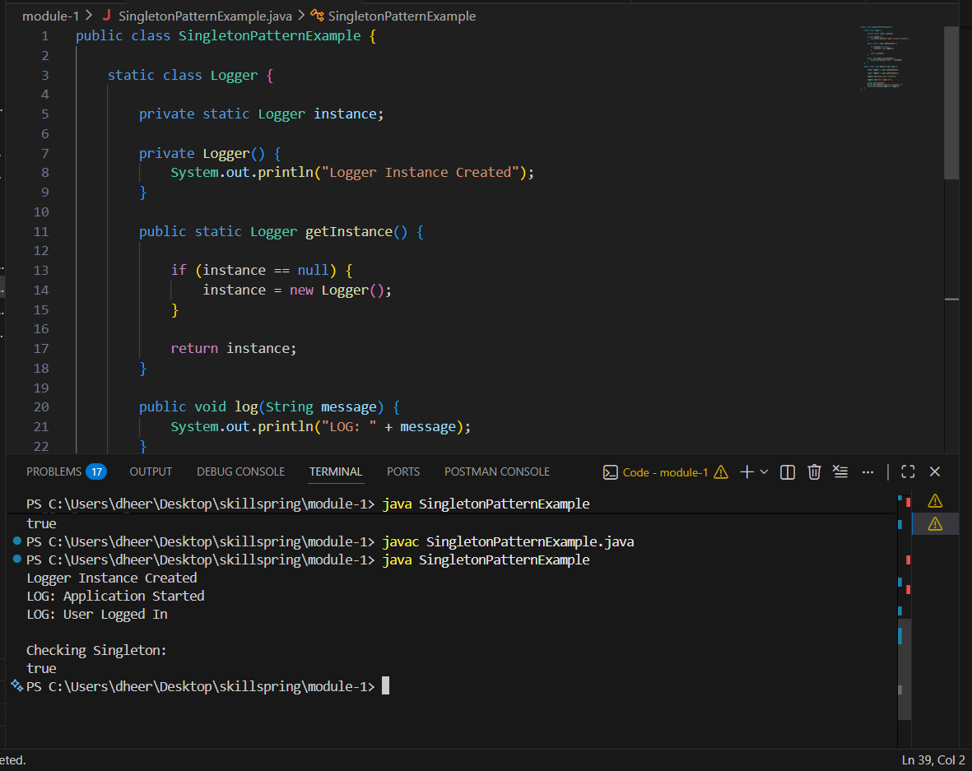
2. FactoryMethodPatternExample
Code:
public class FactoryMethodPatternExample {

interface Document {
void open();
}

static class WordDocument implements Document {

@Override
public void open() {
System.out.println("Opening Word Document");
}
}

static class PdfDocument implements Document {

@Override
public void open() {
System.out.println("Opening PDF Document");
}
}

static class ExcelDocument implements Document {

@Override
public void open() {
System.out.println("Opening Excel Document");
}
}

static abstract class DocumentFactory {

public abstract Document createDocument();
}

static class WordDocumentFactory extends DocumentFactory {

@Override
public Document createDocument() {
return new WordDocument();
}
}

static class PdfDocumentFactory extends DocumentFactory {

@Override
public Document createDocument() {
return new PdfDocument();
}
}

static class ExcelDocumentFactory extends DocumentFactory {

@Override
public Document createDocument() {
return new ExcelDocument();
}
}

public static void main(String[] args) {

DocumentFactory wordFactory =
new WordDocumentFactory();

DocumentFactory pdfFactory =
new PdfDocumentFactory();

DocumentFactory excelFactory =
new ExcelDocumentFactory();

Document wordDoc =
wordFactory.createDocument();

Document pdfDoc =
pdfFactory.createDocument();

Document excelDoc =
excelFactory.createDocument();

wordDoc.open();
pdfDoc.open();
excelDoc.open();
}
}
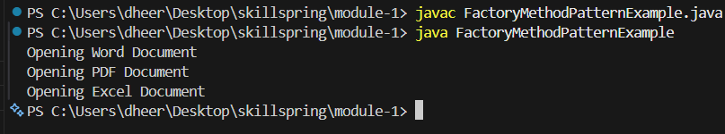
3. BuilderPatternExample
Code:
public class BuilderPatternExample {

static class Computer {

private String cpu;
private String ram;
private String storage;
private String graphicsCard;
private String operatingSystem;

private Computer(Builder builder) {

this.cpu = builder.cpu;
this.ram = builder.ram;
this.storage = builder.storage;
this.graphicsCard = builder.graphicsCard;
this.operatingSystem = builder.operatingSystem;
}

public void displayConfiguration() {

System.out.println("Computer Configuration");
System.out.println("----------------------");
System.out.println("CPU : " + cpu);
System.out.println("RAM : " + ram);
System.out.println("Storage : " + storage);
System.out.println("Graphics Card : " + graphicsCard);
System.out.println("Operating System : " + operatingSystem);
}

static class Builder {

private String cpu;
private String ram;
private String storage;
private String graphicsCard;
private String operatingSystem;

public Builder setCPU(String cpu) {
this.cpu = cpu;
return this;
}

public Builder setRAM(String ram) {
this.ram = ram;
return this;
}

public Builder setStorage(String storage) {
this.storage = storage;
return this;
}

public Builder setGraphicsCard(String graphicsCard) {
this.graphicsCard = graphicsCard;
return this;
}

public Builder setOperatingSystem(String operatingSystem) {
this.operatingSystem = operatingSystem;
return this;
}

public Computer build() {
return new Computer(this);
}
}
}

public static void main(String[] args) {

Computer gamingComputer =
new Computer.Builder()
.setCPU("Intel i9")
.setRAM("32GB")
.setStorage("1TB SSD")
.setGraphicsCard("RTX 4070")
.setOperatingSystem("Windows 11")
.build();

Computer officeComputer =
new Computer.Builder()
.setCPU("Intel i5")
.setRAM("16GB")
.setStorage("512GB SSD")
.setOperatingSystem("Windows 11")
.build();

System.out.println("Gaming Computer");
gamingComputer.displayConfiguration();

System.out.println();

System.out.println("Office Computer");
officeComputer.displayConfiguration()} }
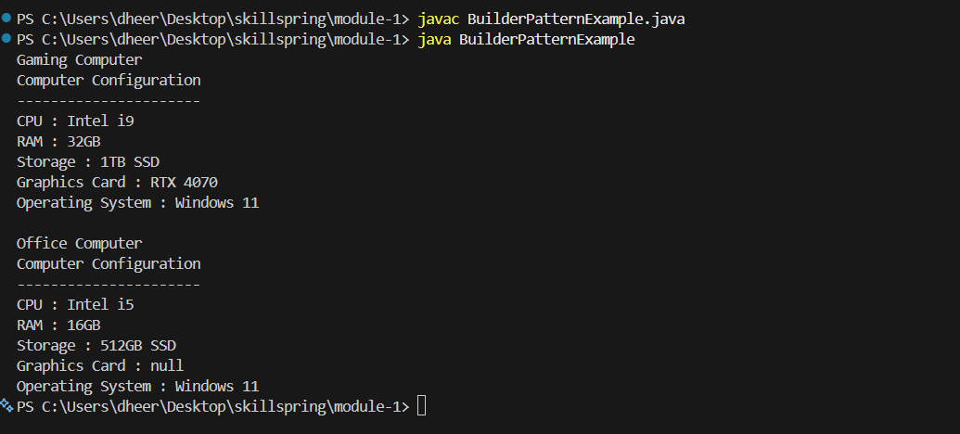
4. Adapter Pattern
Code:
public class AdapterPatternExample {

interface PaymentProcessor {
void processPayment(double amount);
}

static class PayPalGateway {
public void makePayment(double amount) {
System.out.println("Payment processed using PayPal: Rs." + amount);
}
}

static class StripeGateway {
public void payAmount(double amount) {
System.out.println("Payment processed using Stripe: Rs." + amount);
}
}

static class PayPalAdapter implements PaymentProcessor {

private PayPalGateway payPalGateway;

public PayPalAdapter(PayPalGateway payPalGateway) {
this.payPalGateway = payPalGateway;
}

@Override
public void processPayment(double amount) {
payPalGateway.makePayment(amount);
}
}

static class StripeAdapter implements PaymentProcessor {

private StripeGateway stripeGateway;

public StripeAdapter(StripeGateway stripeGateway) {
this.stripeGateway = stripeGateway;
}

@Override
public void processPayment(double amount) {
stripeGateway.payAmount(amount);
}
}

public static void main(String[] args) {

PaymentProcessor paypal =
new PayPalAdapter(new PayPalGateway());

PaymentProcessor stripe =
new StripeAdapter(new StripeGateway());

paypal.processPayment(1000);
stripe.processPayment(2500);
}
}
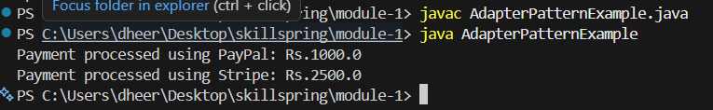
5. Decorator Pattern
Code:
public class DecoratorPatternExample {

interface Notifier {
void send(String message);
}

static class EmailNotifier implements Notifier {

@Override
public void send(String message) {
System.out.println("Email Notification: " + message);
}
}

static abstract class NotifierDecorator implements Notifier {

protected Notifier notifier;

public NotifierDecorator(Notifier notifier) {
this.notifier = notifier;
}

@Override
public void send(String message) {
notifier.send(message);
}
}

static class SMSNotifierDecorator
extends NotifierDecorator {

public SMSNotifierDecorator(Notifier notifier) {
super(notifier);
}

@Override
public void send(String message) {
super.send(message);
System.out.println("SMS Notification: " + message);
}
}

static class SlackNotifierDecorator
extends NotifierDecorator {

public SlackNotifierDecorator(Notifier notifier) {
super(notifier);
}

@Override
public void send(String message) {
super.send(message);
System.out.println("Slack Notification: " + message);
}
}

public static void main(String[] args) {

Notifier notifier =
new SlackNotifierDecorator(
new SMSNotifierDecorator(
new EmailNotifier()));

notifier.send("Server is running");
}
}

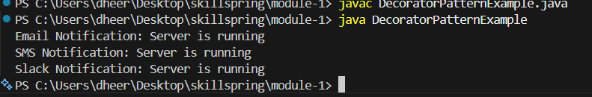

6.Proxy Pattern
Code:
public class ProxyPatternExample {

interface Image {
void display();
}

static class RealImage implements Image {

private String fileName;

public RealImage(String fileName) {
this.fileName = fileName;
loadFromServer();
}

private void loadFromServer() {
System.out.println(
"Loading image from remote server: "
+ fileName);
}

@Override
public void display() {
System.out.println(
"Displaying image: " + fileName);
}
}

static class ProxyImage implements Image {

private RealImage realImage;
private String fileName;

public ProxyImage(String fileName) {
this.fileName = fileName;
}

@Override
public void display() {

if(realImage == null) {
realImage =
new RealImage(fileName);
}

realImage.display();
}
}

public static void main(String[] args) {

Image image =
new ProxyImage("nature.jpg");

System.out.println("First Display");
image.display();

System.out.println();

System.out.println("Second Display");
image.display();
}
}
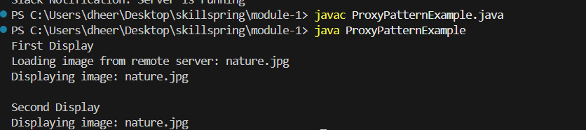
7. Observer Pattern Example
Code:
import java.util.ArrayList;
import java.util.List;

public class ObserverPatternExample {

interface Observer {
void update(String stockName,
double stockPrice);
}

interface Stock {
void registerObserver(
Observer observer);

void deregisterObserver(
Observer observer);

void notifyObservers();
}

static class StockMarket
implements Stock {

private List<Observer> observers =
new ArrayList<>();

private String stockName;
private double stockPrice;

@Override
public void registerObserver(
Observer observer) {
observers.add(observer);
}

@Override
public void deregisterObserver(
Observer observer) {
observers.remove(observer);
}

@Override
public void notifyObservers() {

for(Observer observer
: observers) {

observer.update(
stockName,
stockPrice);
}
}

public void setStock(
String stockName,
double stockPrice) {

this.stockName = stockName;
this.stockPrice = stockPrice;

notifyObservers();
}
}

static class MobileApp
implements Observer {

private String user;

public MobileApp(String user) {
this.user = user;
}

@Override
public void update(
String stockName,
double stockPrice) {

System.out.println(
"Mobile App [" + user +
"] -> " +
stockName +
" : Rs." +
stockPrice);
}
}

static class WebApp
implements Observer {

private String user;

public WebApp(String user) {
this.user = user;
}

@Override
public void update(
String stockName,
double stockPrice) {

System.out.println(
"Web App [" + user +
"] -> " +
stockName +
" : Rs." +
stockPrice);
}
}

public static void main(String[] args) {

StockMarket market =
new StockMarket();

Observer mobileUser =
new MobileApp("Dheeraj");

Observer webUser =
new WebApp("Admin");

market.registerObserver(
mobileUser);

market.registerObserver(
webUser);

market.setStock(
"TCS",
4200.50);

System.out.println();

market.setStock(
"Infosys",
1850.75);
}
}
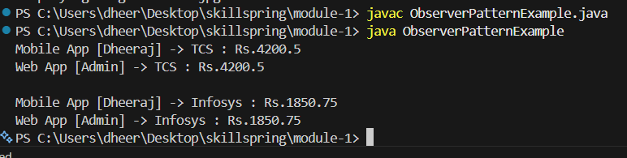
8. Strategy Pattern Example
Code:
public class StrategyPatternExample {

interface PaymentStrategy {
void pay(double amount);
}

static class CreditCardPayment
implements PaymentStrategy {

private String cardNumber;

public CreditCardPayment(
String cardNumber) {

this.cardNumber = cardNumber;
}

@Override
public void pay(double amount) {

System.out.println(
"Paid Rs." + amount +
" using Credit Card: "
+ cardNumber);
}
}

static class PayPalPayment
implements PaymentStrategy {

private String email;

public PayPalPayment(
String email) {

this.email = email;
}

@Override
public void pay(double amount) {

System.out.println(
"Paid Rs." + amount +
" using PayPal: "
+ email);
}
}

static class PaymentContext {

private PaymentStrategy strategy;

public void setStrategy(
PaymentStrategy strategy) {

this.strategy = strategy;
}

public void executePayment(
double amount) {

strategy.pay(amount);
}
}

public static void main(String[] args) {

PaymentContext context =
new PaymentContext();

context.setStrategy(
new CreditCardPayment(
"1234-5678-9999"));

context.executePayment(5000);

context.setStrategy(
new PayPalPayment(
"user@gmail.com"));

context.executePayment(2500);
}
}
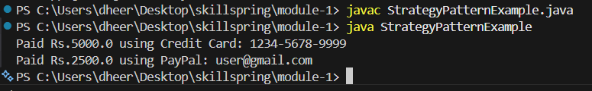
9. Command Pattern Example
Code:
public class CommandPatternExample {

interface Command {
void execute();
}

static class Light {

public void turnOn() {
System.out.println(
"Light is ON");
}

public void turnOff() {
System.out.println(
"Light is OFF");
}
}

static class LightOnCommand
implements Command {

private Light light;

public LightOnCommand(
Light light) {

this.light = light;
}

@Override
public void execute() {
light.turnOn();
}
}

static class LightOffCommand
implements Command {

private Light light;

public LightOffCommand(
Light light) {

this.light = light;
}

@Override
public void execute() {
light.turnOff();
}
}

static class RemoteControl {

private Command command;

public void setCommand(
Command command) {

this.command = command;
}

public void pressButton() {

command.execute();
}
}

public static void main(String[] args) {

Light light = new Light();

Command onCommand =
new LightOnCommand(light);

Command offCommand =
new LightOffCommand(light);

RemoteControl remote =
new RemoteControl();

remote.setCommand(
onCommand);

remote.pressButton();

remote.setCommand(
offCommand);

remote.pressButton();
}
}
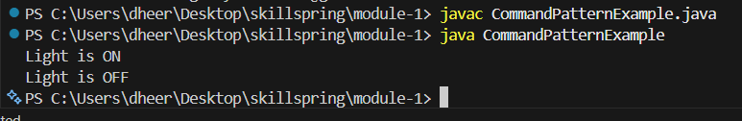
10. MVC Pattern
Code:
public class MVCPatternExample {

static class Student {

private int id;
private String name;
private String grade;

public Student(
int id,
String name,
String grade) {

this.id = id;
this.name = name;
this.grade = grade;
}

public int getId() {
return id;
}

public String getName() {
return name;
}

public String getGrade() {
return grade;
}

public void setName(
String name) {

this.name = name;
}

public void setGrade(
String grade) {

this.grade = grade;
}
}

static class StudentView {

public void displayStudentDetails(
Student student) {

System.out.println(
"Student Details");

System.out.println(
"ID : " +
student.getId());

System.out.println(
"Name : " +
student.getName());

System.out.println(
"Grade : " +
student.getGrade());
}
}

static class StudentController {

private Student model;
private StudentView view;

public StudentController(
Student model,
StudentView view) {

this.model = model;
this.view = view;
}

public void setStudentName(
String name) {

model.setName(name);
}

public void setStudentGrade(
String grade) {

model.setGrade(grade);
}

public void updateView() {

view.displayStudentDetails(
model);
}
}

public static void main(String[] args) {

Student student =
new Student(
101,
"Dheeraj",
"A");

StudentView view =
new StudentView();

StudentController controller =
new StudentController(
student,
view);

controller.updateView();

System.out.println();

controller.setStudentGrade(
"A+");

controller.updateView();
} }
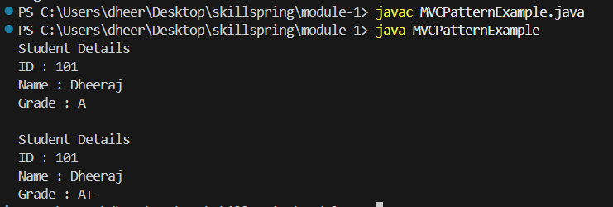
11. Dependency Injection Example
Code:
public class DependencyInjectionExample {

interface CustomerRepository {

String findCustomerById(
int id);
}

static class CustomerRepositoryImpl
implements CustomerRepository {

@Override
public String findCustomerById(
int id) {

return "Customer ID : "
+ id +
" Name : Dheeraj";
}
}

static class CustomerService {

private CustomerRepository repository;

public CustomerService(
CustomerRepository repository) {

this.repository =
repository;
}

public void getCustomer(
int id) {

String customer =
repository
.findCustomerById(id);

System.out.println(
customer);
}
}

public static void main(String[] args) {

CustomerRepository repository =
new CustomerRepositoryImpl();

CustomerService service =
new CustomerService(
repository);

service.getCustomer(101);
}
}
